-----------------------------------Sai---------------hive------------------

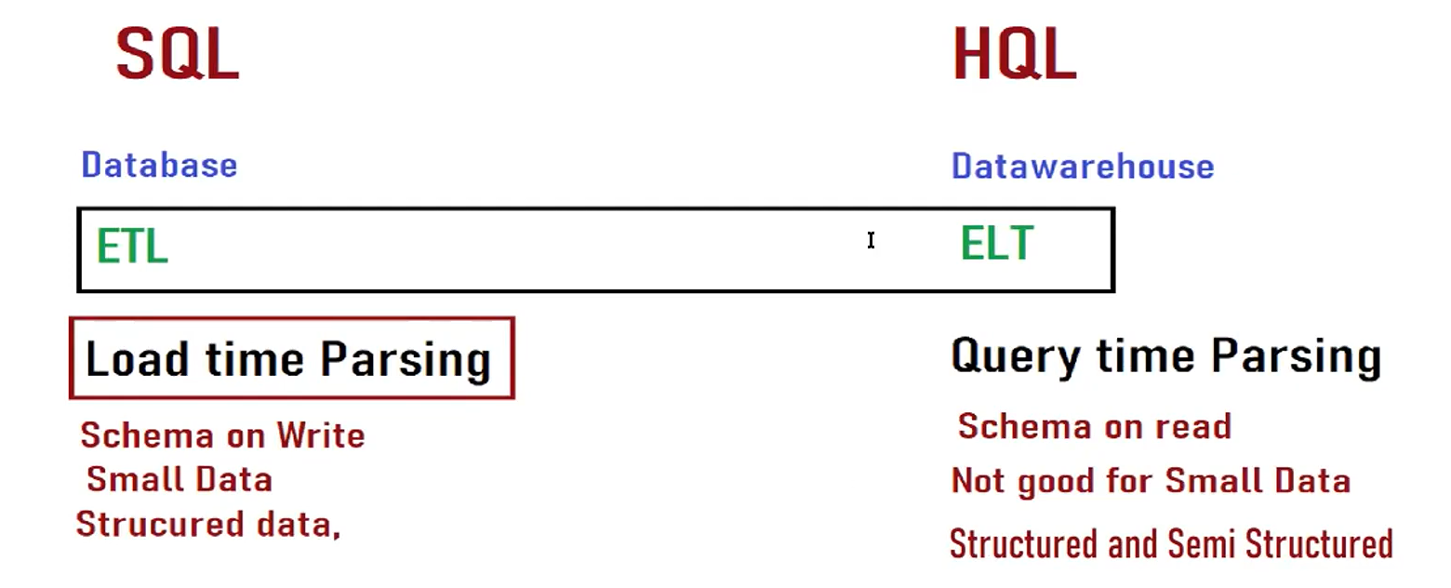

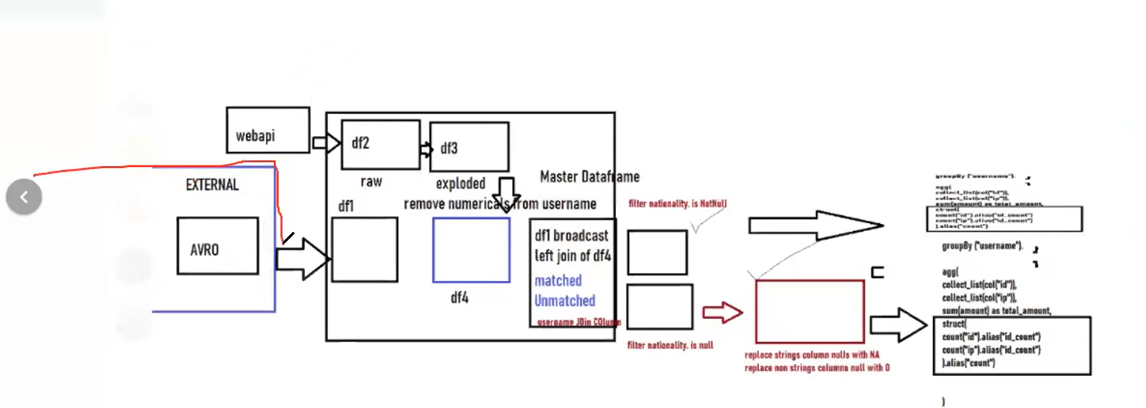

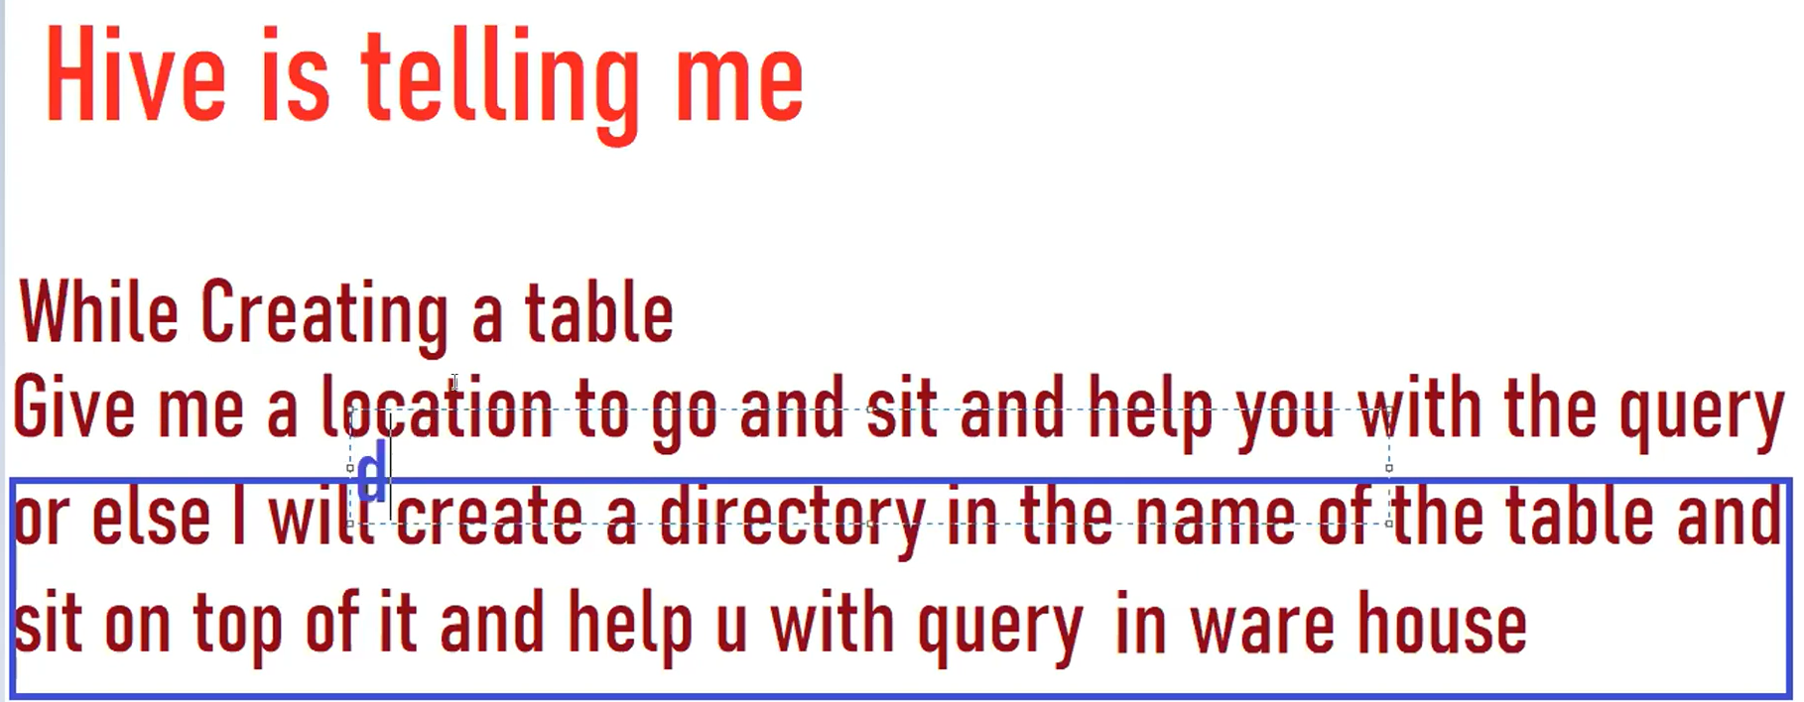

-------------------------------------Hive---------------------------------------------------------------------------

--sqoop can not exort semi structured data.....

--create table customermod10 ( custid INT, firstname VARCHAR(20), lastname VARCHAR(20), city VARCHAR(50), age INT, createdt date, transactamt int );

load data infile '/home/cloudera/data.parquet' into table customermod10 fields terminated by ',';

scala> val df = spark.read.format("csv").option("delimiter",",").option("header","true").load("/user/cloudera/data_customer/part-m-00000")

--creating table uder /user/hive/warehouse/db_name/table_name (by default)

create table txnrecords(txnno INT, txndate STRING, custno INT, amount DOUBLE, category STRING, product STRING, city STRING, state STRING, spendby STRING)

row format delimited

fields terminated by ','

lines terminated by '\n'

stored as textfile;

use default;

alter table txnrecords rename to zeyocheck.txnrecors;

use zeyocheck;

load data local inpath '/home/cloudera/data/txns' into table txnrecords;

select * from txnrecords limit 10;

--if data is got deleted from hdfs, need to put txns from edge node to hdfs

hdfs dfs -ls /user/hive/warehouse/zeyocheck.db/txnrecords

hdfs dfs -rmr /user/hive/warehouse/zeyocheck.db/txnrecords/txns

select * from txnrecords limit 10;

hdfs dfs -put '/home/cloudera/data/txns' /user/hive/warehouse/zeyocheck.db/txnrecords

hdfs dfs -mkdir /user/cloudera/datadir

hdfs dfs -put '/home/cloudera/data/txns' /user/cloudera/datadir

--creating table on /user/cloudera/datadir

--table txnrecords_loc poiting to the direcotry /user/cloudera/datadir

create table txnrecords_loc(txnno INT, txndate STRING, custno INT, amount DOUBLE, category STRING, product STRING, city STRING, state STRING, spendby STRING)

row format delimited

fields terminated by ','

lines terminated by '\n'

stored as textfile

location '/user/cloudera/datadir';

create table txnrecords_target(txnno INT, txndate STRING, custno INT, amount DOUBLE, category STRING, product STRING, city STRING, state STRING, spendby STRING)

row format delimited

fields terminated by ','

lines terminated by '\n'

stored as textfile;

insert into txnrecords_target select * from txnrecords_loc

hdfs dfs -ls /user/hive/warehouse/zeyocheck/txnrecords_target

--to show database name

hive> set hive.cli.print.current.db=ture;

--drop both the tables and check back in directory

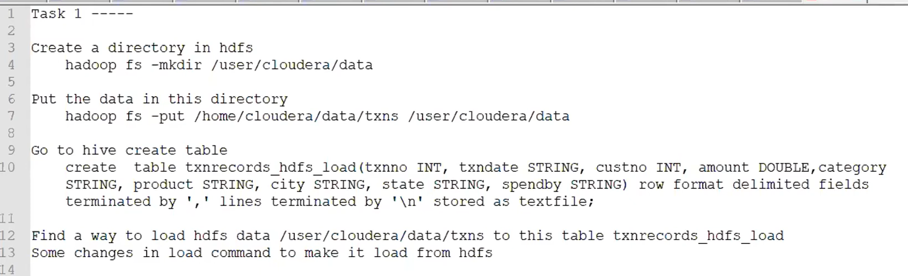

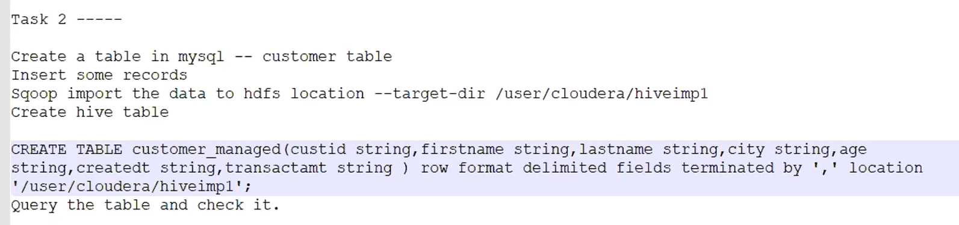

Static insert partitions:

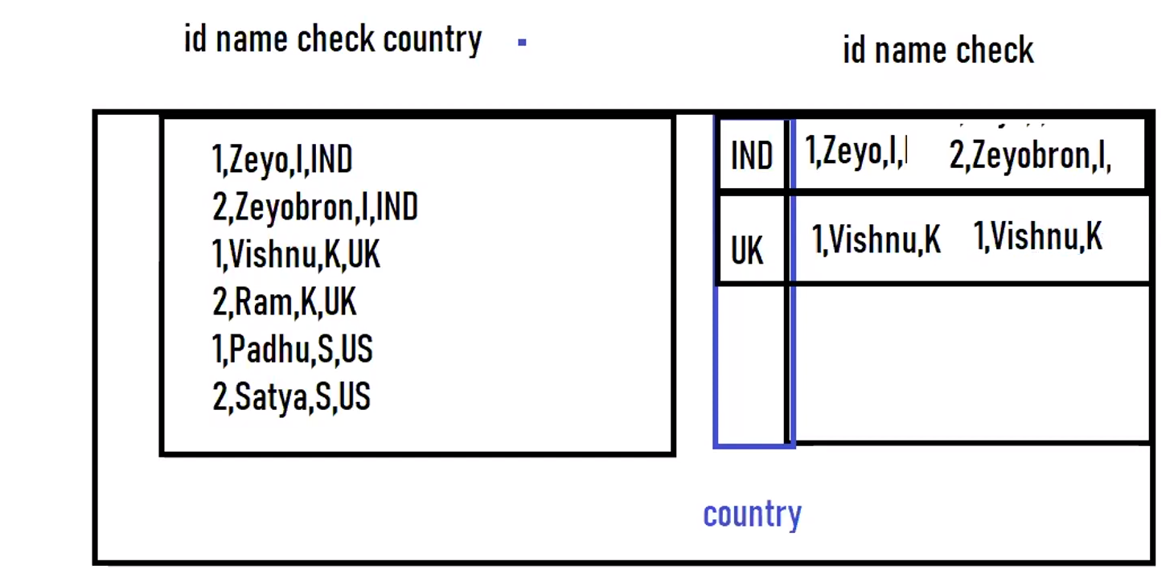

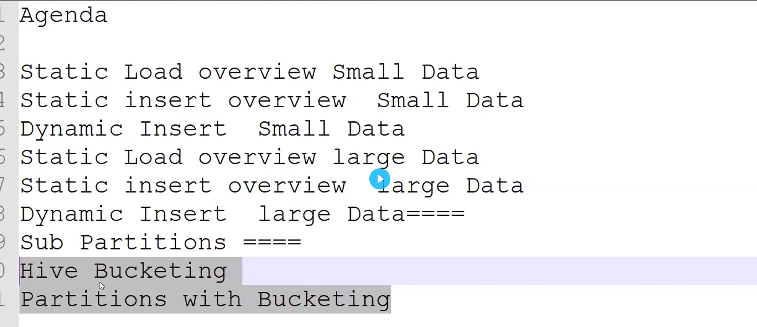

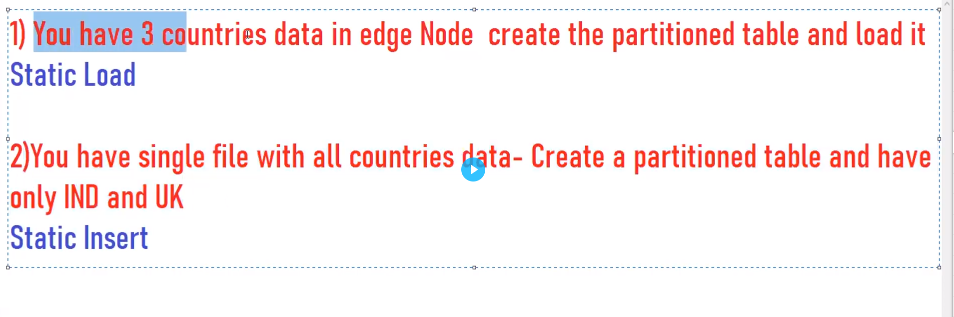

For large countries, static insert takes long time.

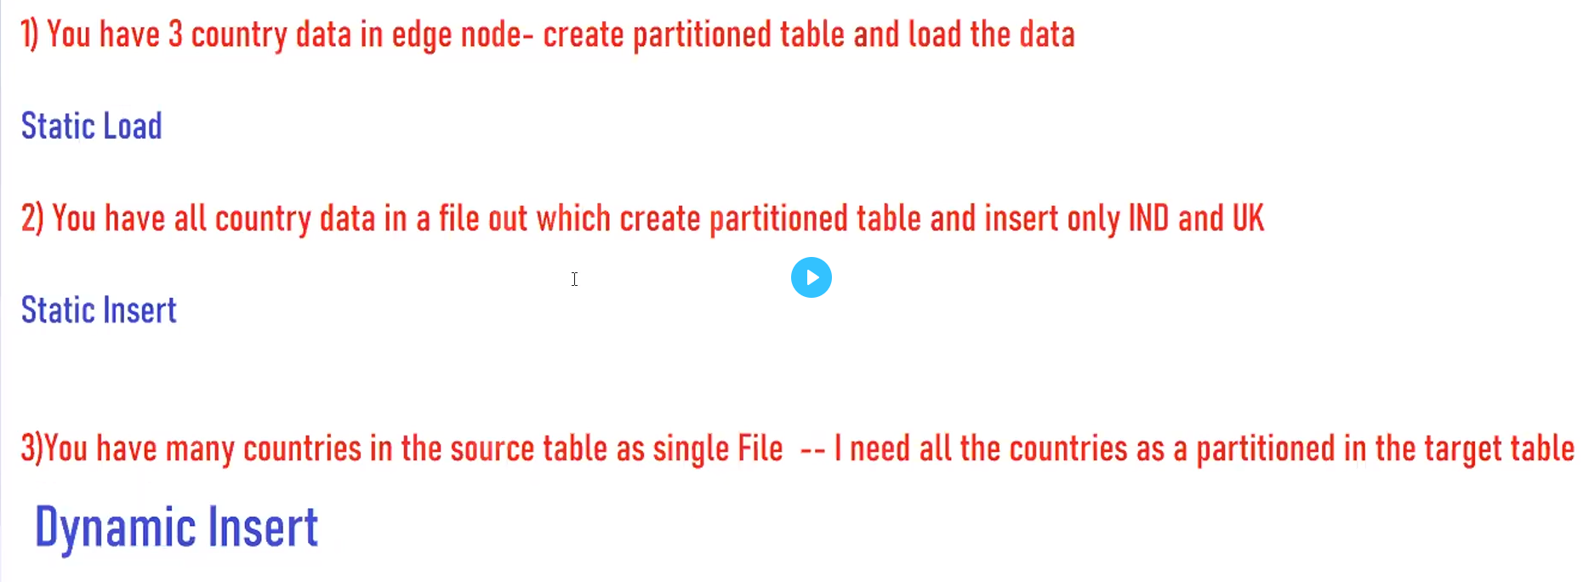

set hive.exec.dynamic.partition.mode=nonstrict;

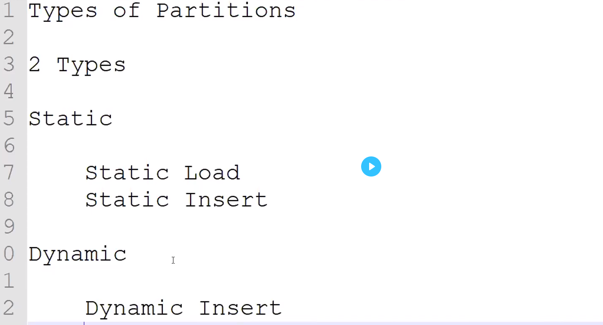

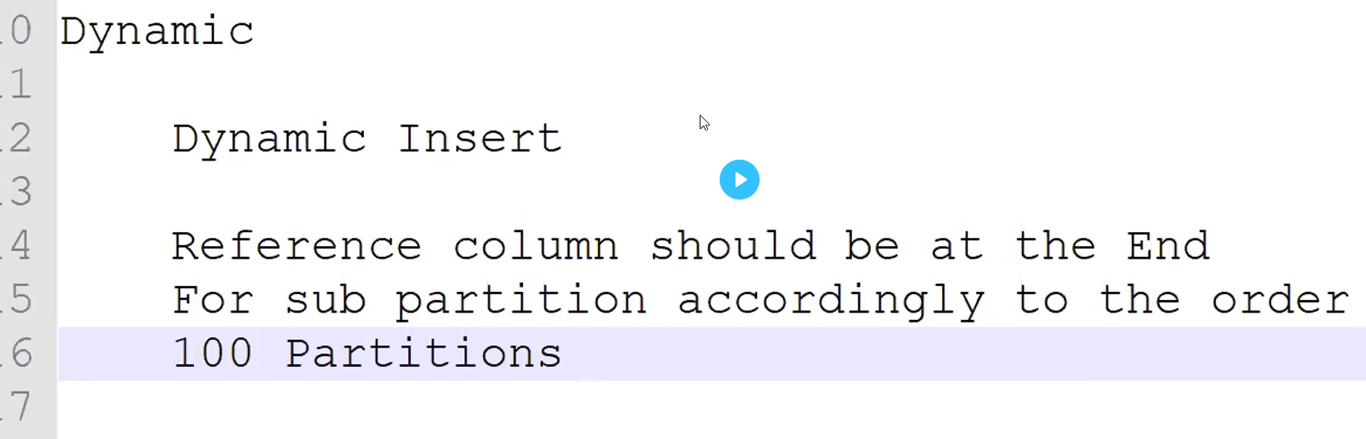

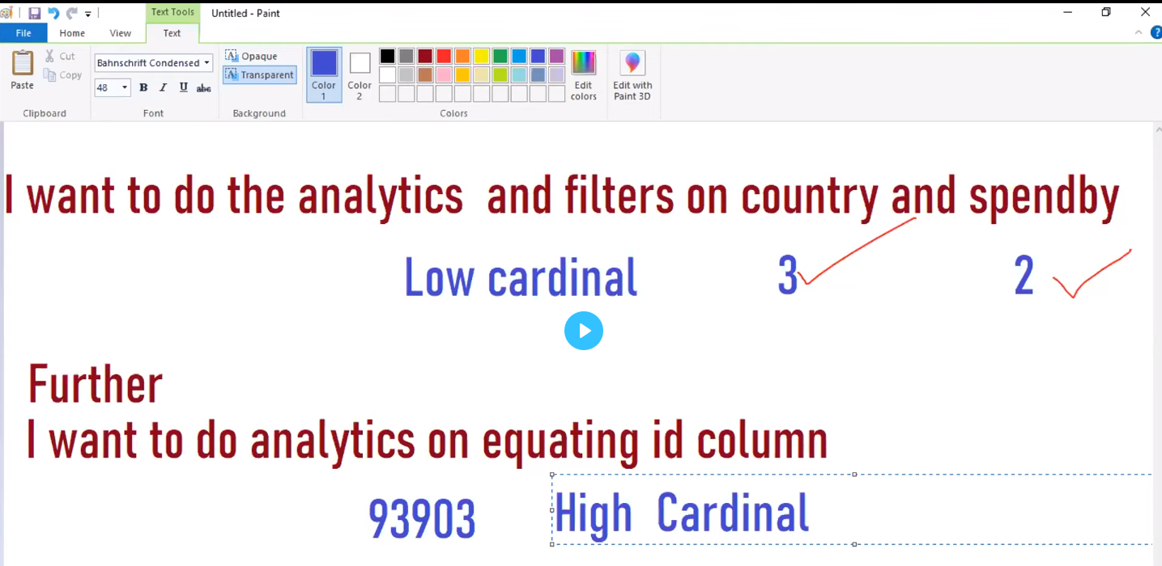

High cardinal , partitions may not help. So, bucketing concept came.

1. Partitions are folder creation but bucketing is file creation.
2. Need to give column and number of buckets

On what logic divided the data:

1. Number of buckets = number of files created

select count(1) from tabelname where country = 'IND' and spendby ='cash' and id='2035'

Limitations of bucketing:

1. Writes takes hell of time (query time, processing time)
2. I will help you till the equating it.

Txnno>2035 ------------0th file

1. It will work anonymously on string columns even though they mention hash algorithms on string data.

Hashing----ascii-----it will modulo

Advantages of bucketing:

Equating columns, it will provide you the best results. It will help you for joins

Hive approximately take 10 s to launch a job. 1 minutes for large data set. for small dataset, it will approximately 2 seconds. For small data, it will consume the cluster power unnecessarily.

-------------------------------------------------------------------------------------------------------------------------

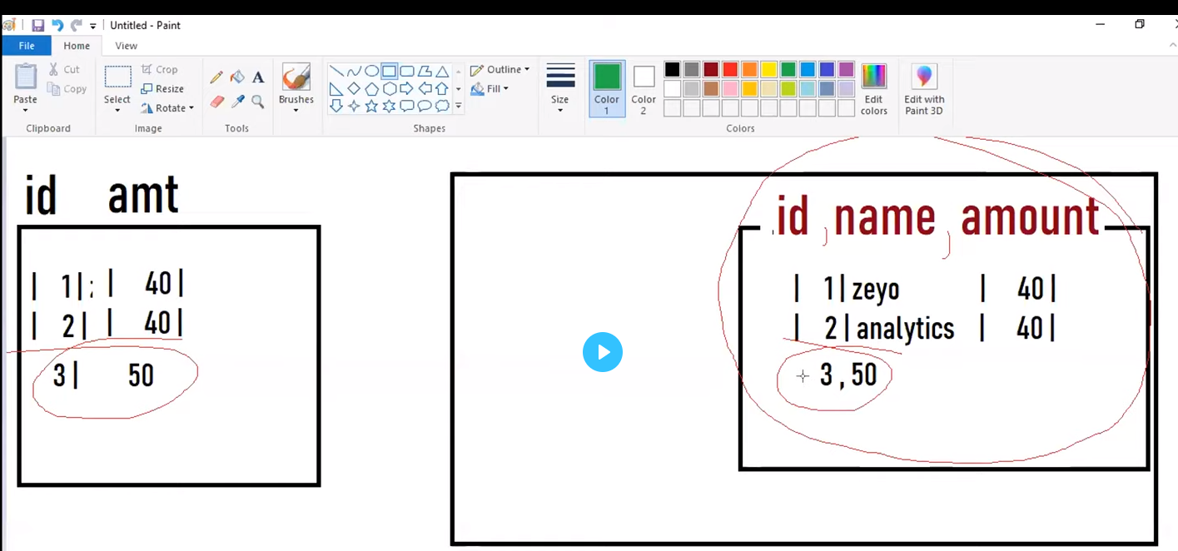

mysql>create database avorcheck

mysql>create table customer (id int, name string, amt int)

mysql>insert into customer values (1, "zeyo", 40)

mysql>insert into customer values (2, "analytics", 40)

sqoop import --connect jdbc:mysql://localhost/avrocheck --username cloudera --password cloudera --table customer -m 1

--target-dir /user/cloudera/text_data

hdfs dfs -cat /user/cloudera/text_data

hive>create table text_tab(id int, name string, amount int) row format delimited fields terminated by ','

location '/user/cloudera/text_data

alter table customer drop column name;

mysql>insert into customer values (3, 50)

sqoop import --connect jdbc:mysql://localhost/avrocheck --username cloudera --password cloudera --table customer -m 1

--target-dir /user/cloudera/text_data --incremental-append --check-columns --last-value 3

hdfs dfs -ls /user/cloudera/text_data

hdfs dfs -ls /user/cloudera/text_data/part-m-00000

hdfs dfs -ls /user/cloudera/text_data/part-m-00001

--## issues above are fields are dropped in mysql after we sqoop import, schema not matched.

* Source is keep changing the columns
* Hive is not supporting with Schema evolutions as text file.
* Solutions is avro file format.

select * text_tab ;

-----------------

--issues above are fields are dropped in mysql after we sqoop import, schema not matched.

--import the data as avro file and it will be resolved.

-----------------------

sqoop import --connect jdbc:mysql://localhost/avrocheck --username cloudera --password cloudera --table customer -m 1

--target-dir /user/cloudera/avro_data --as-avrodatafile

hdfs dfs -ls /user/cloudera/avro_data

hive>create external table avrodata_tab

ROW FORMAT SERDE 'org.apache.hadoop.hive.serde2.avro.AvroSerDe'

STORED AS AVRO

location '/user/cloudera/avro_data'

TBLPROPERTIES ('avro.schema.url' = '/user/cloudera/avro_avsc_dir/customer_new.avsc');

hive>select * from avrodata_tab;

mysql>alter table customer drop column name;

mysql>insert into cusotmer values(4,100)

sqoop import --connect jdbc:mysql://localhost/avrocheck --username cloudera --password cloudera --table customer -m 1

--target-dir /user/cloudera/text_data --incremental-append --check-columns --last-value 3 --as-avrodatafile

select * from avrodata_tab;

--data which corresponding column is deleted , show null in that place.

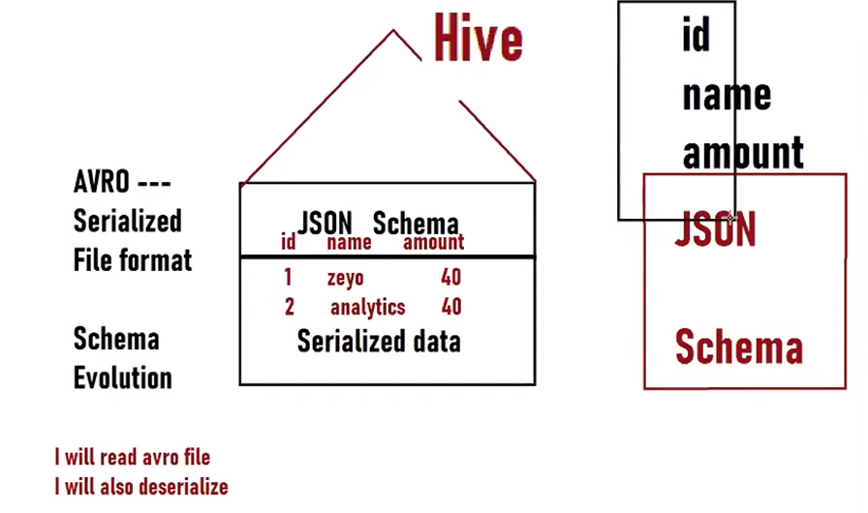

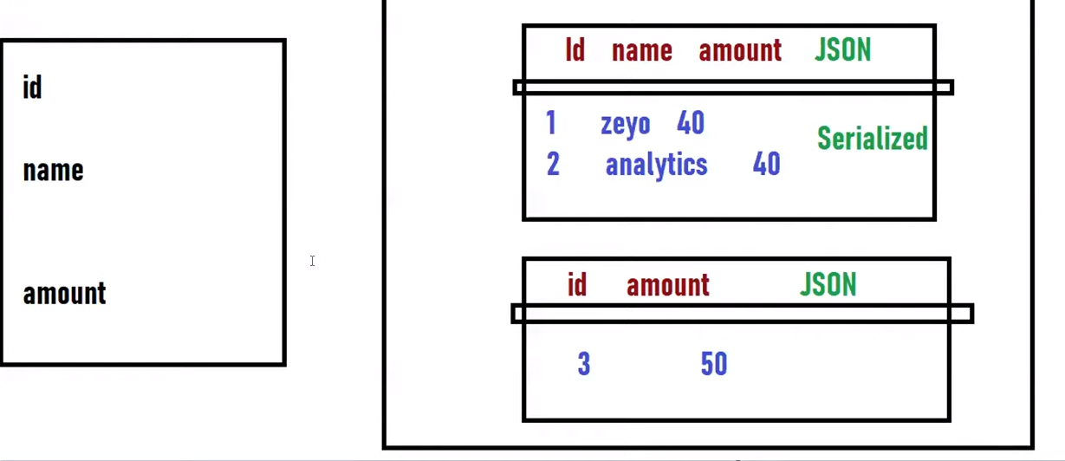

Schema is tightly coupled with data. We have to maintain separate schema in separate file. Which columns to consume decided by schema file. Each part file has schema file and data file.

If any column is deleted in json schema in hdfs location, still we can read data in hive by select * from table name.

When sqoop import –as-avrodatafile, we will get java and avsc file as well. Avsc file is schema file. Avsc is generated in edgenode and data is pushed in hdfs. Need to put avsc in hdfs as well.

1. Data and schema is tightly coupled.
2. Which columns to pull from that file will be decided by the schema file.

------aws with hive----------------

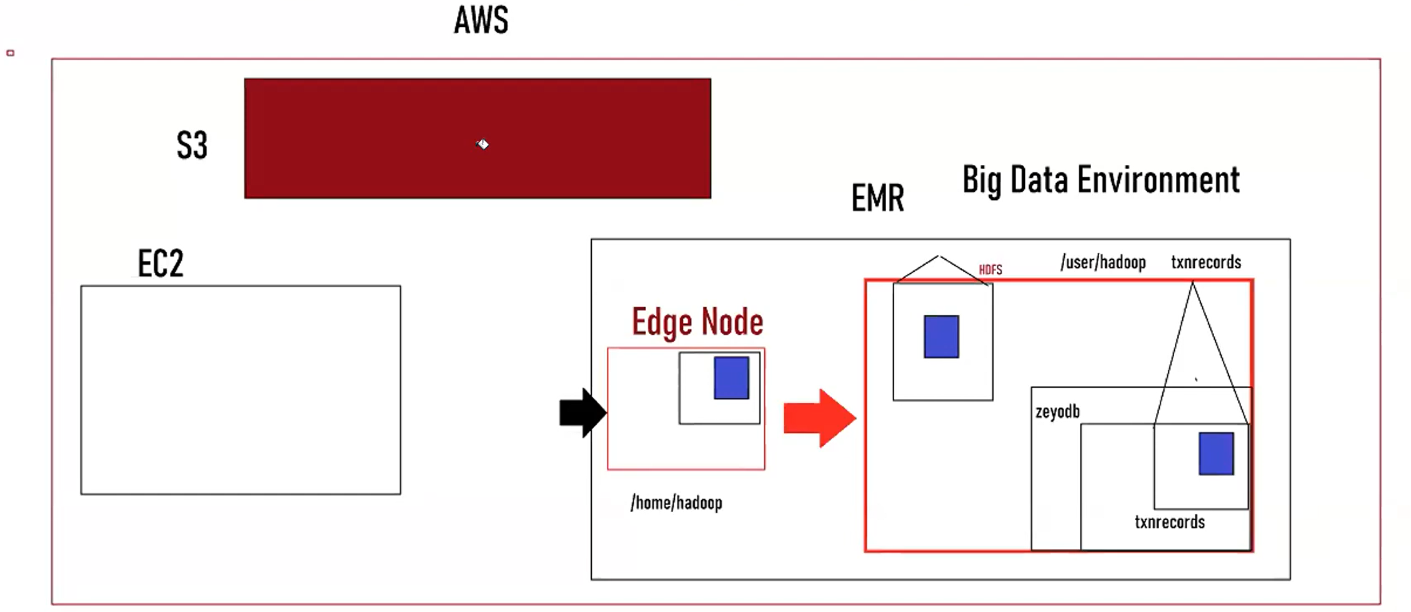

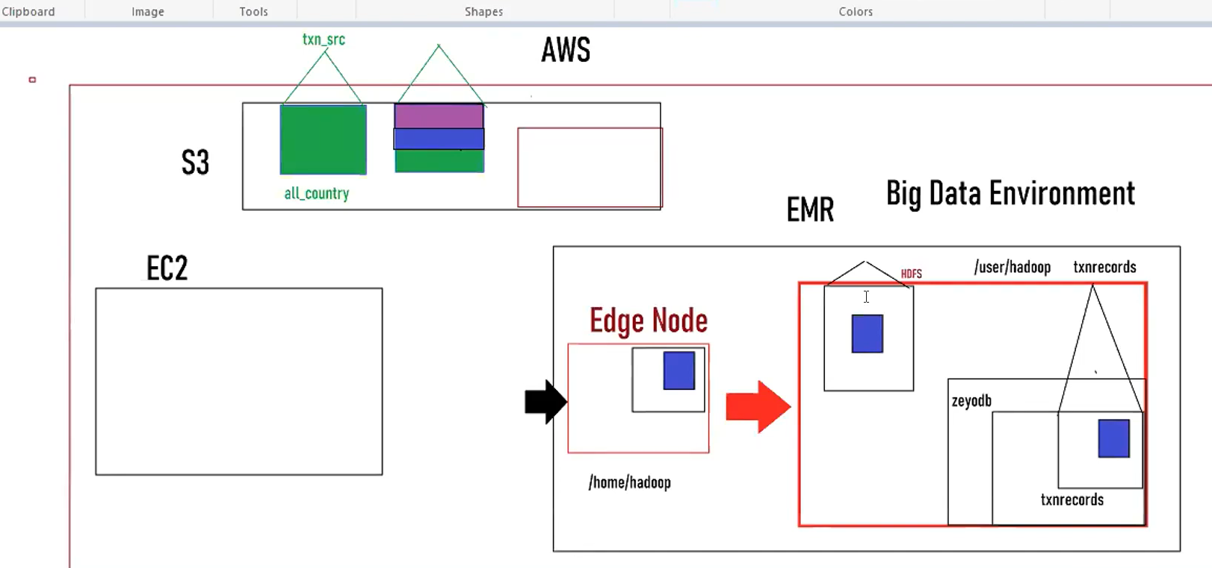

-------------------aws hive cloud integration-------------------------------------------------

--------- EMR--------------

hadoop

pwd

/home/hadoop/

hdfs dfs -ls /user/

hdfs dfs -ls /user/hadoop/

hive

create database zeyod;

use zeyod;

hdfs dfs -ls /user/hive/warehouse/

show tables;

create table txnrecords(txnno INT, txndate STRING, custno INT, amount DOUBLE, category STRING, product STRING, city STRING, state STRING, spendby STRING)

row format delimited

fields terminated by ','

lines terminated by '\n'

stored as textfile;

hdfs dfs -ls /user/hive/warehouse/zeyod.db/

--winscp to aws edgenode to copy data from windows to edgenode of aws

load data local inpath /home/hadoop/data/txns into table txnrecords

hdfs dfs -mkdir /user/hadoop/txn_dir

ls

cd data

hdfs dfs -put txns /user/hadoop/txn_dir

hdfs dfs -ls /

--creating hive table in external location on the top of /user/hadoop/txn_dir

create table txnrecords_loc(txnno INT, txndate STRING, custno INT, amount DOUBLE, category STRING, product STRING, city STRING, state STRING, spendby STRING)

row format delimited

fields terminated by ','

lines terminated by '\n'

stored as textfile

location '/user/hadoop/txn_dir';

select * from txnrecords_loc limit 10;

drop table txnrecords_loc;

hdfs dfs -put txns /user/hadoop/txn_dir

-------------s3-----------------------

--inside amazon s3, zeyobucket/data/txns, copy url for location

--creating hive table on top of this directroy on s3

use zeyod;

create table txnrecords1_s3(txnno INT, txndate STRING, custno INT, amount DOUBLE, category STRING, product STRING, city STRING, state STRING, spendby STRING)

row format delimited

fields terminated by ','

lines terminated by '\n'

stored as textfile

location 's3a://zeyonifibucket/data/';

select * from txnrecords1_s3 limit 10;

describe formatted txnrecords1_s3;

drop table txnrecords1_s3;

--create directory with all_country_name in s3, upload all_country from downloads from windows

create table txnrecords1_src(txnno INT, txndate STRING, custno INT, amount DOUBLE, category STRING, product STRING, city STRING, state STRING, spendby string ,country_check string, country string)

row format delimited

fields terminated by ','

lines terminated by '\n'

stored as textfile

location 's3a://zeyohivebucket/all_country_dir/';

select * from txnrecords1_src limit 10;

create table txnrecords1_src(txnno INT, txndate STRING, custno INT, amount DOUBLE, category STRING, product STRING, city STRING, state STRING, spendby string ,country_check string)

partitioned by (country string, spendby string)

--clustered by (txnno) into 3 buckets

row format delimited

fields terminated by ','

lines terminated by '\n'

stored as textfile

location 's3a://zeyohivebucket/partition_dest/';

--check in s3, partition_dest directory is created and table also create

insert into txn_dest partition (country)

select txnno, txndate, custno, amount, category, product, city,state, spendby, country_check from txn_src;

--check in s3 under partition_dest directory, we saw partitions uk, usa and ind with file part starting with 00000_0 and so on

--tez not work in cloudera

------------data transfer from --s3 to cloudera

--just try to make cloudera environment as EMR--------------

cloudera login

pwd

sudo vi /etc/hadoop/conf/core-site.xml

hive

--in s3, i have a bucket, inside bucket, i have folder with all_country.csv file. Hive on cloudera can go

--to remote and query all_country.csv from s3 remotely , need to do some configuration.

--hive table on cloudera with location s3 (s3a://zeyohivebucket/all_country_dir/ without updating configuration

--s3, s3a, s3n

create table txn_src(txnno INT, txndate STRING, custno INT, amount DOUBLE, category STRING, product STRING, city STRING, state STRING, spendby string ,country_check string, country string)

row format delimited

fields terminated by ','

lines terminated by '\n'

stored as textfile

location 's3a://zeyohivebucket/all_country_dir/';

select * from txn_src limit 10;

--failed connection, table is created and pointing but need to authenticate.

sudo vi /etc/hadoop/conf/core-site.xml

--add configuration property first name as fs.s3a.access.key and second as fs.s3a.secret.key and third as fs.defaultFS

hive

select * from txn_src limit 10;

set hive.exec.dynamic.partition.mode = nonstrict;

create table txn_tt(txnno INT, txndate STRING, custno INT, amount DOUBLE, category STRING, product STRING, city STRING, state STRING, spendby string ,country_check string)

partitioned by (country string)

row format delimited

fields terminated by ','

lines terminated by '\n'

stored as textfile

location 's3a://zeyohivebucket/all_lpd_dir/';

insert into txn_dest partition (contry string)

select txnno, txndate, custid, custno, amount, category, product, city,state, spendby, country_check, country from txn_src;

--to check directory is created or not

--cloudera terminal, remove all existing .aws

rm -rf /home/cloudera/.aws

aws configure

access key

secret key

ap-south-1

--it will show the directory is created or not

aws s3 ;s s3://zeyohivebucket/

aws s3 ;s s3://zeyohivebucket/all_country_dir/

aws s3 ;s s3://zeyohivebucket/all_country_dir/country=IND/

-------------------------------hadoop revision------------------------------------------------------------

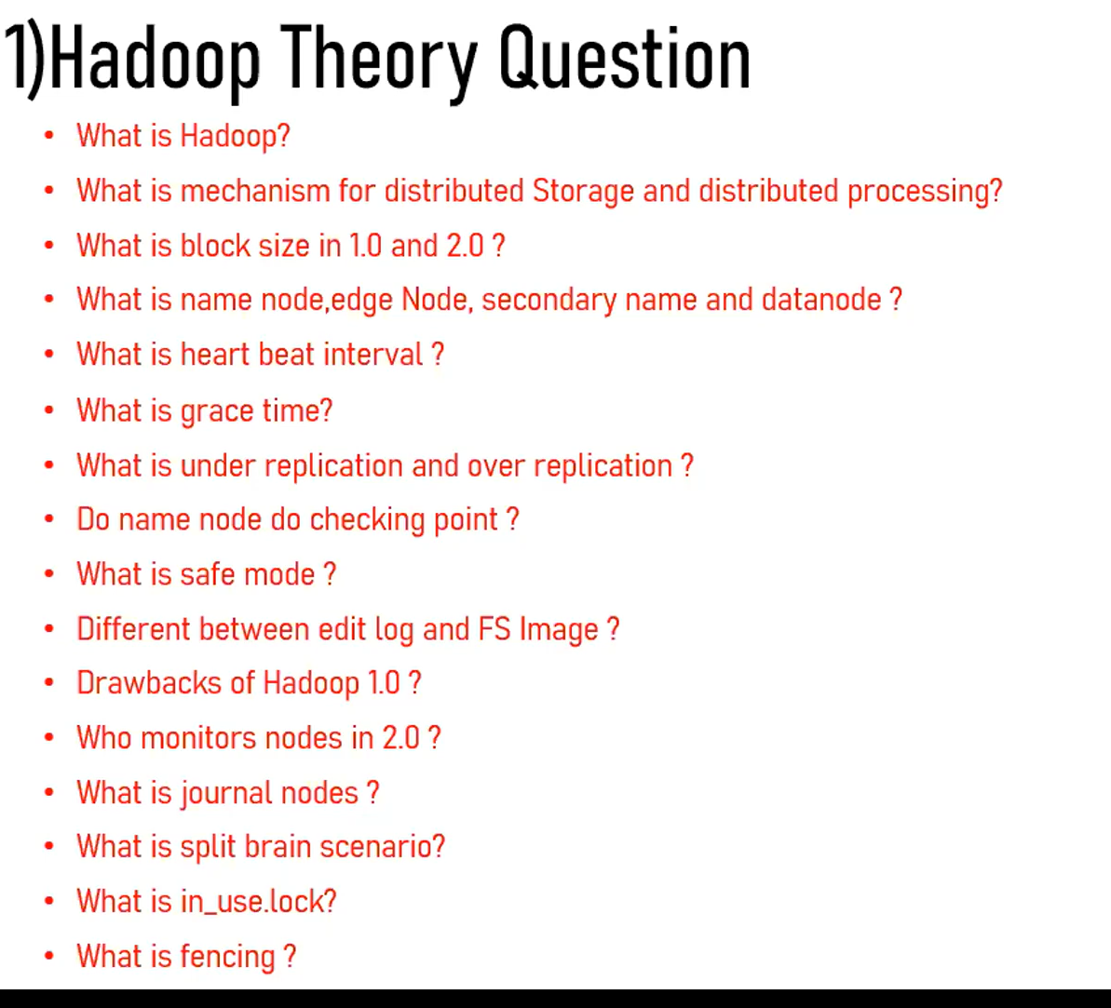

--------------------------------azure hive ------------------------------------------------------------------

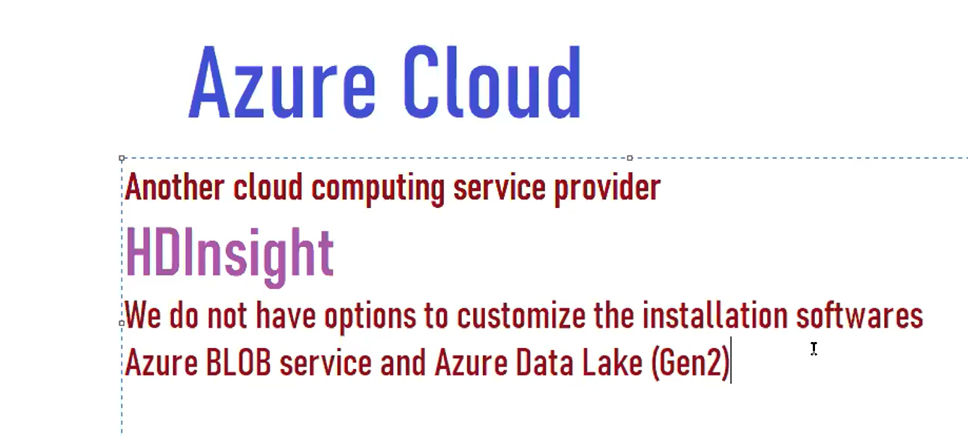

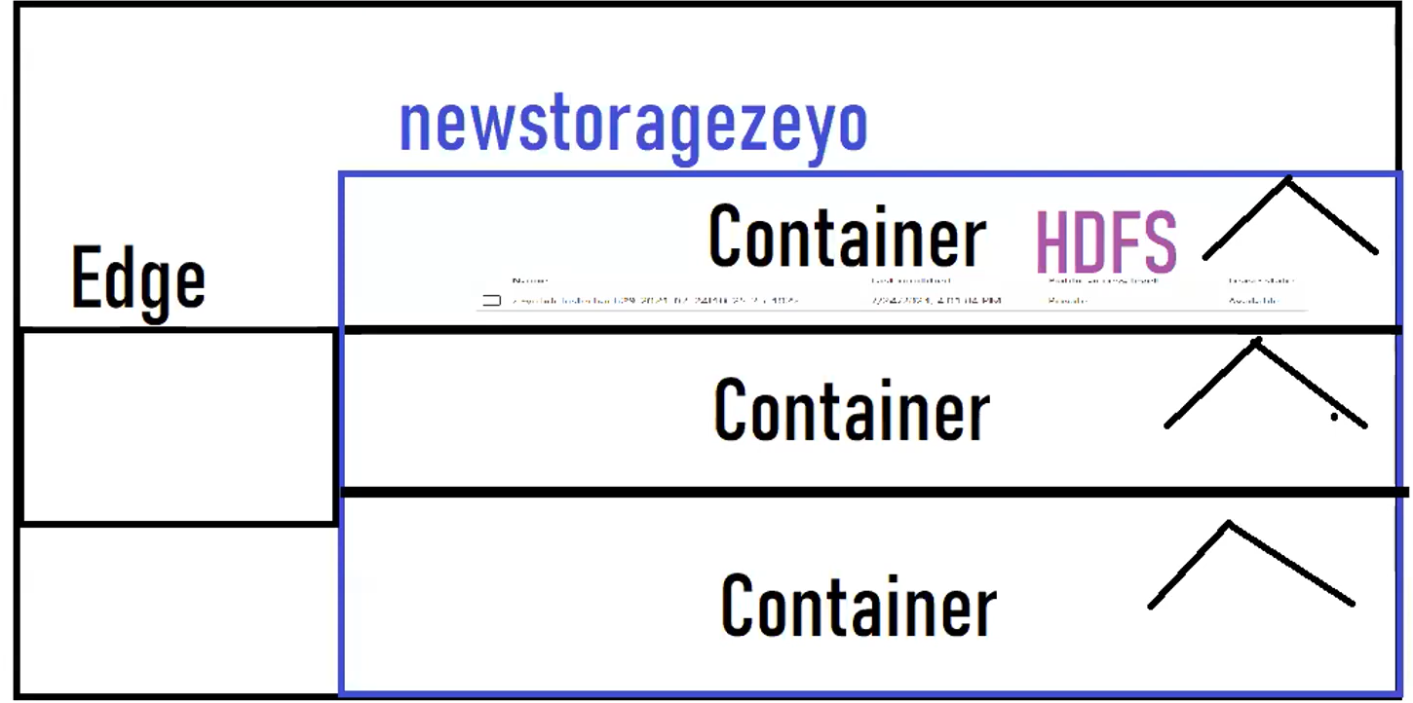

-Azure portal , hdinsight, Hadoop (quite fixed all components unlike aws have more options to select )

-create hdinsight cluster, new storage account = newstoragezeyo

-aws hive can be created on the hdfs in EMR and s3 as well

-in azure, hive can be created on the top of hdfs and other containers as well.

--storage, newstoragezeyo, blob, hdfs hcontainers, all user folder seen under this containers.

--storage account=>containers=>folders

--click on plus sign to create other container ,named as zeyocontainer , container after creation generally not contain hdfs.

--hdfs is found inside the continaer and insed hdfs, we have hive and so on.

--hive can be created on the top of container containing hdfs and any other new container.

--ssh+cluster login , copy, putty ssh ,

--list Hadoop folders, folders got populated.

Hadoop fs -ls /

Hadoop fs -ls /user

Hadoop fs -touchz /user/ambari-qa/sample

Putty:

Azure url: [sshuser@zeyohdclusterbach29-ssh.azurehdinsight.net](mailto:sshuser@zeyohdclusterbach29-ssh.azurehdinsight.net)

Password: Aditya@usa908

Pwd

--to start hive

/usr/bin/hive

Hive> create database zeyodb;

--by default hive storage is /hive/warehouse/zeyodb.db with hivesampletable default

Use zeyodb;

Create table test (id int);

--table will be blob

Insert into test values (1);

Describe formatted test;

Drop table managed_table;

Drop table test;

Hadoop fs -mkdir /user/txn

--use winscp to bring data from windows to edgenode of azure zyohdcluster29

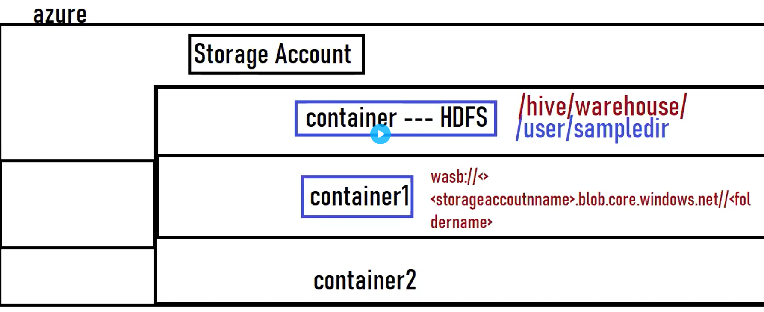

-------------------------map join--------------------------------------------------------------

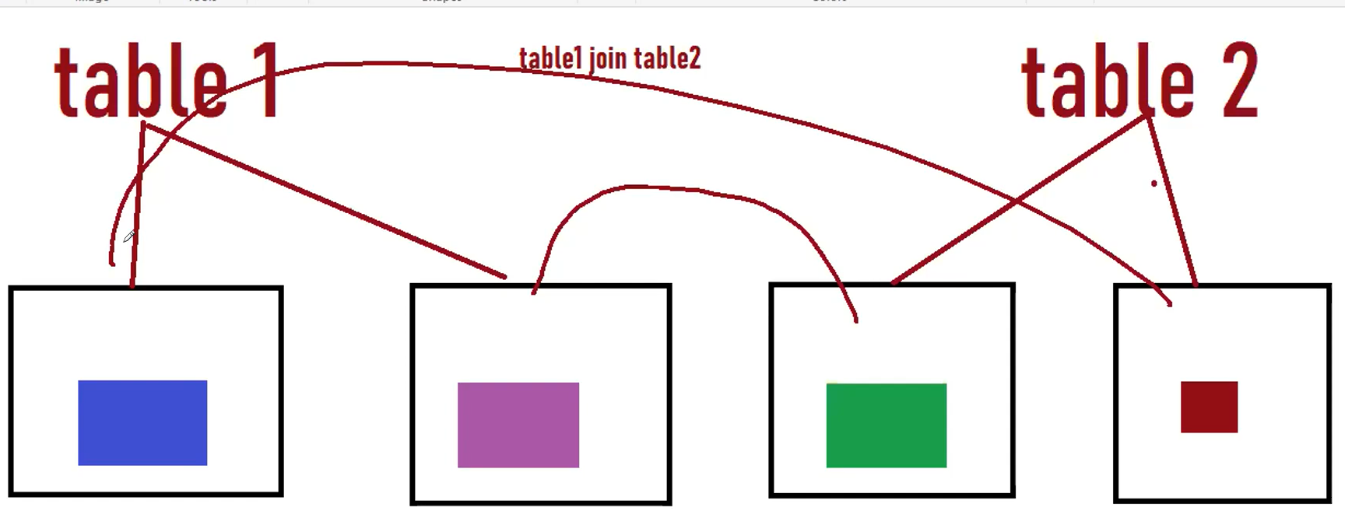

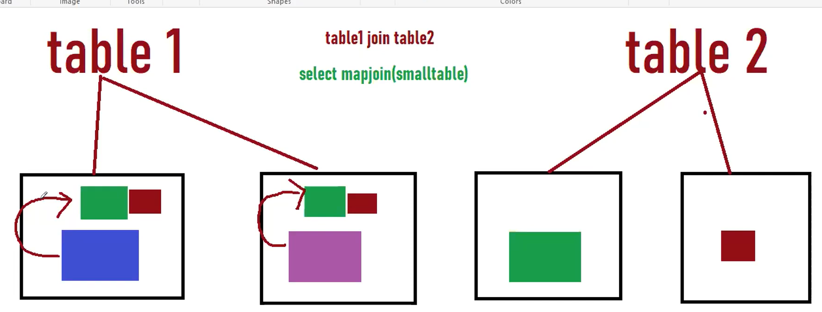

--lot of shuffling happened. Once it will map or join and then reducers come into play.

--select mapjoin (small table), here table2 is small.

--all the blocks of small table will go and sitting all the nodes of large table. Large blocks of large table doesn’t need to go and search the blocks of small table.

--In the mapper side itself, the joining will happen.

--Memory consumption might happen as entire table will go to all nodes and cached.

--broadcast the small dataframe, and map side join the small table.

--hadoop fs -du /user/cloudera/directory/table1

--In normal join, we might need to use reducers in join but in map side join, no need to use reducers.

Select /*+ mapjoin(s) */ l.key, l.value from s join l on s.key = l.key

----------------bucket map join--------------------------------------

Set hive.optimize.bucketmapjoin=true;

-Enable a property to perform bucket map join

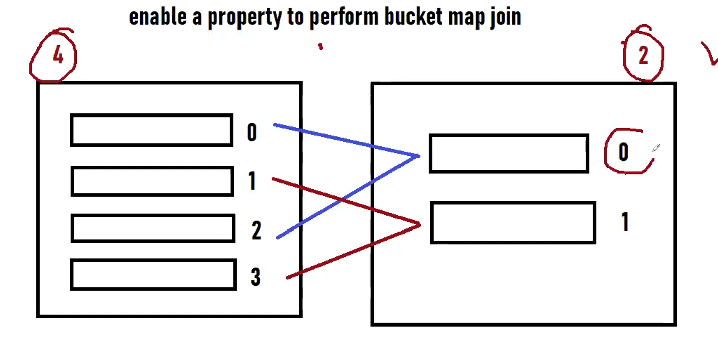

--number of buckets are multiple of one .i.e. 2 *2 =4

--0 join with 0 modulo (0 and 2 )

--1 join with 1 and 3 as modulo remains 1

--Number of buckets are multiple of number of buckets of another table. We will use bucket map join, it will scan only multiple of buckets.

--if number of buckets are not multiple, then it will scan whole data..so it will be full join.

-------------------sort merge bucket map join---------------------------------------------------

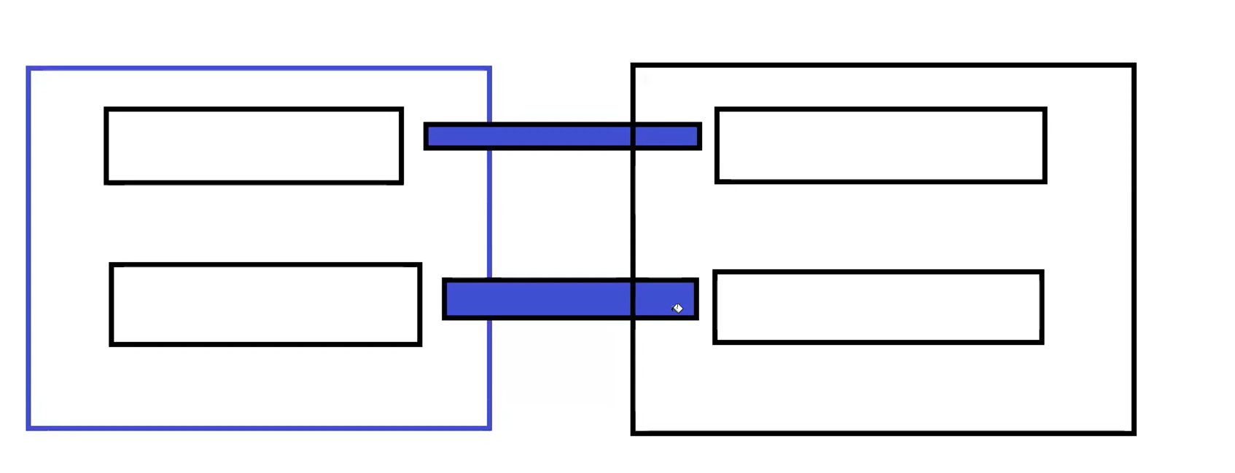

Set hive.auto.convert.sortmerge.join =true;

Set hive.optimize.bucketmapjoin =true;

Set hive.optimize.bucketmapjoin.sortedmerge = true;

Set hive.auto.convert.sortmerge.join.noconditionaltask =true;

--if number of buckets are same, same like bucket to bucket join

---------------------------------Skew join-----------------------------------------------------------

-------------------------Hadoop Yarn-------ma reduce------------------------------

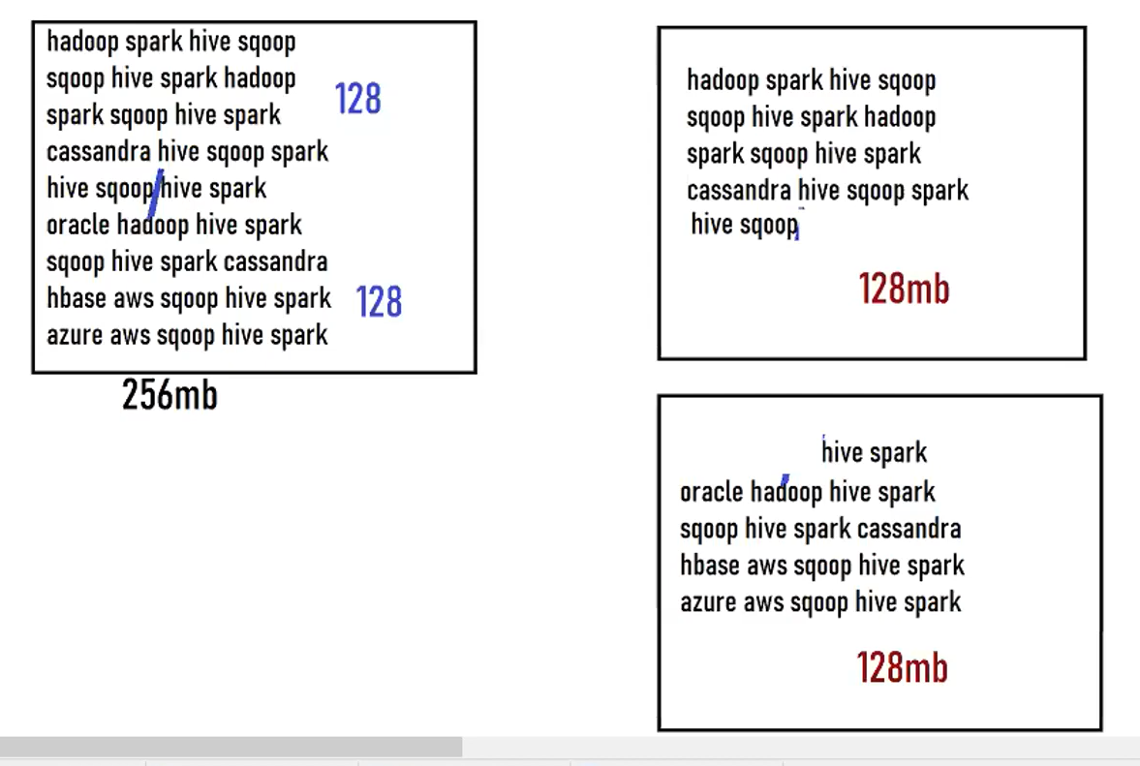

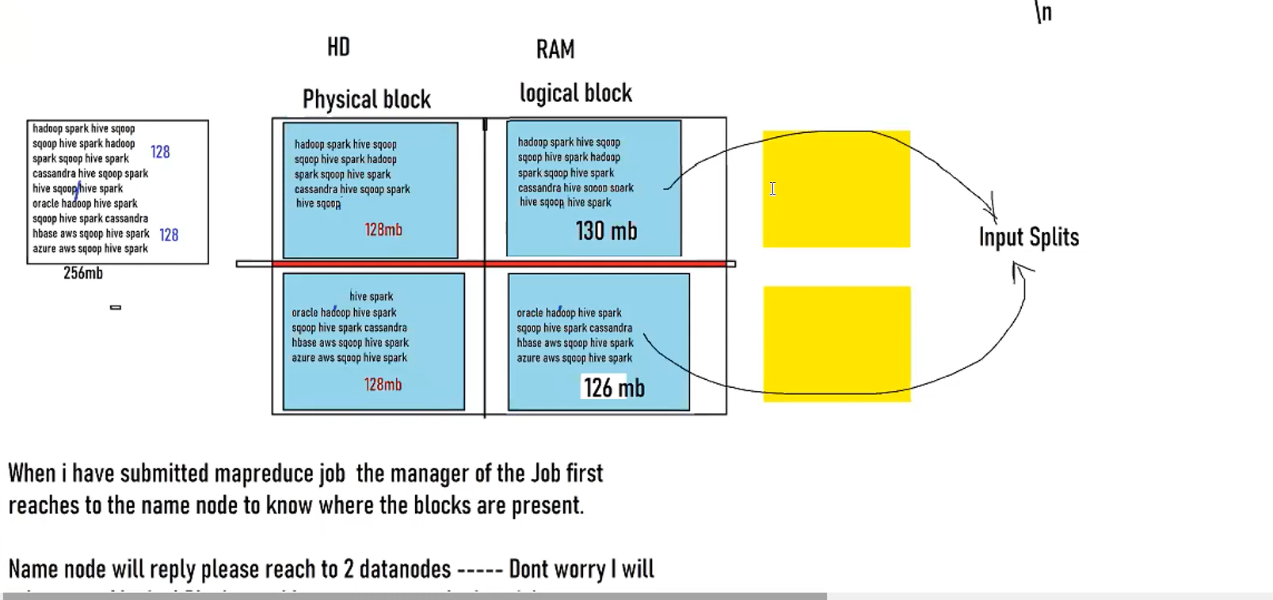

--after physical block, some lines move to other block for line completeness.

--cloudera does not support TEZ ……only Horon works support.

--------------------------hive performance-------------------------------------

1. Partitions
2. Bucketing
3. Map join, bucket map jon, sert merge bucket map join, skew join
4. Tez engine (not exist in Hadoop 1.0)
5. Vectorization of hive ( 1 mapper process 1 row at a time) if you enable vectorization hive mapper process 1024 rows at a time (memeroy)

Set hive.vectorized.execution.enable = true;

Major drawback of vectorization kills memory.

1. Parallel execution

Set hive.exec.parallel = true;

----------------------------------Hadoop 1.0----map reduce--------------------------------------------------

-client first contact with job tracker for job and job tracker connects with namenode and namenode shows the availability of data nodes. Job tracker triggered job for task tracker. Data from physical block in hard disk in data nodes comes to memory as input splits. Only then task tracker process mapper, reducer jobs on input splits.

-every data node coupled with task tracker.

-

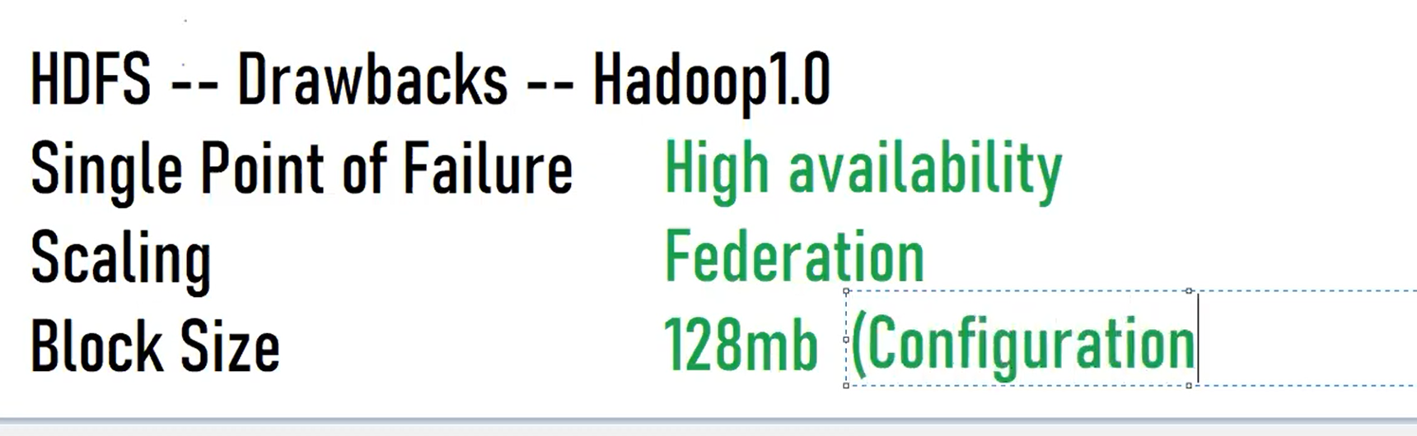

Job tracker -technical managaer

Task tracker-technical team mates

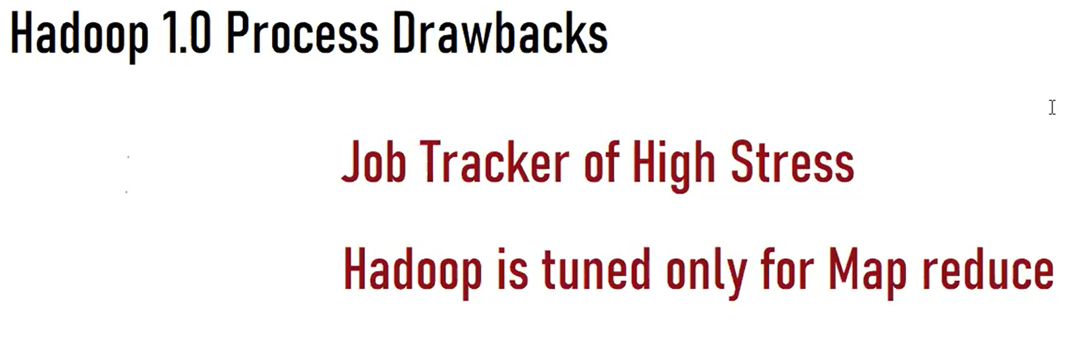

--------------------------Hadoop 2.0---------Yarn------------------------------

-Arun Murthy gave solution for drawbacks of Hadoop 1.0, solution name is YARN.

-yest another resource negotiator

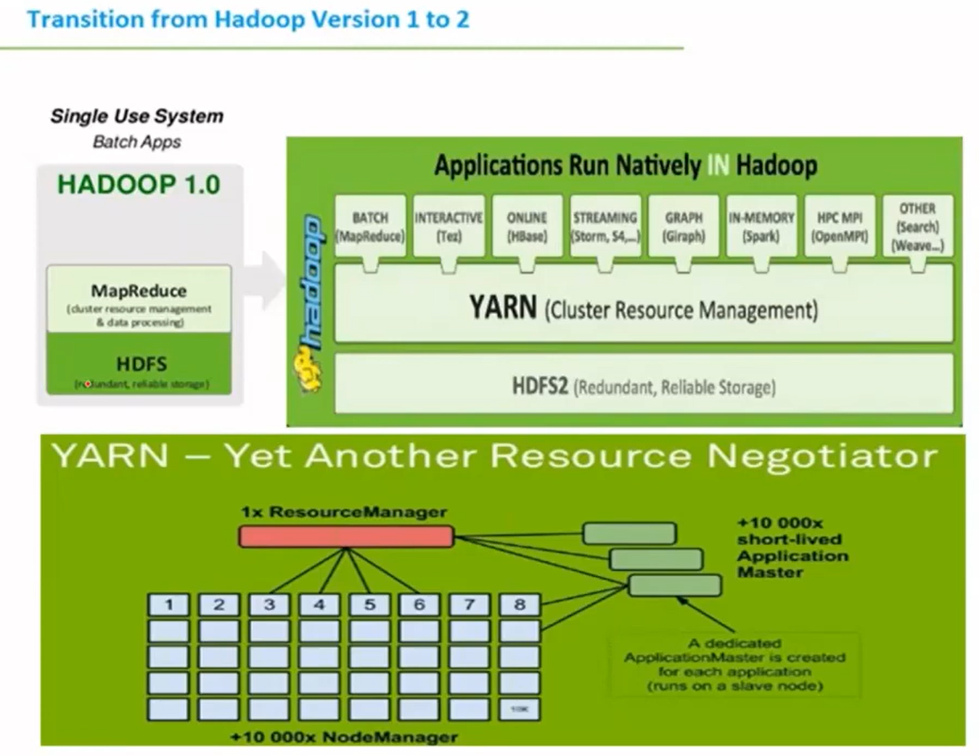

Job tracker renamed as resource manager , task tracker renamed as node manger.



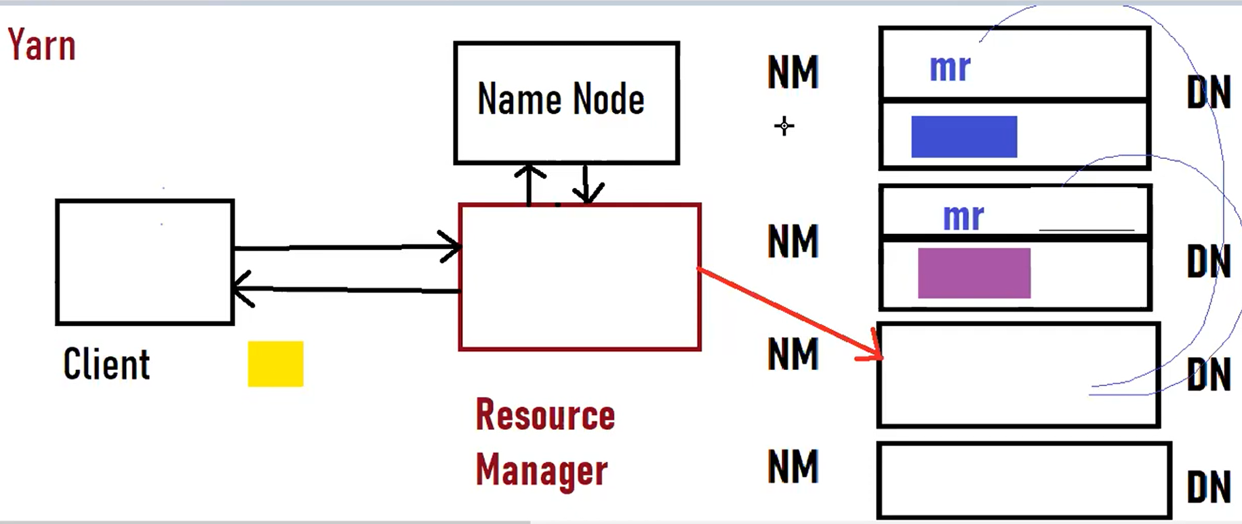

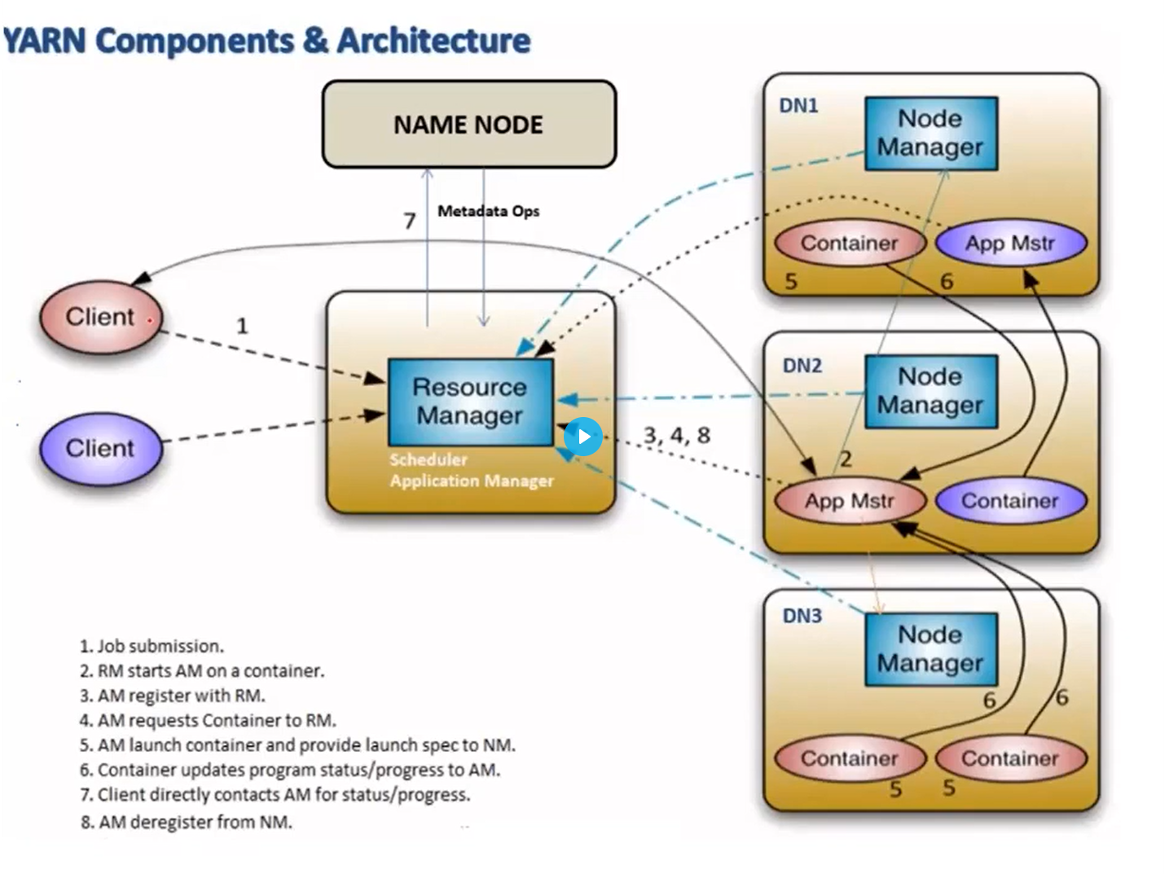

* Each DN is coupled with NN.
* Clients have some jobs to trigger, Client first triggered job to RM first. RM immediately contact the NN ask 2 questions 1) where data node present is and 2) which node to run AM. Immediately NN responded back to RM by giving all info.
* Meanwhile, RM requested the NN to create in memory container where the data present. Also, NN creates the input splits.
* Then RM will create the AM
* AM launch container and AM submitted job to the container.
* Input splits come inside the container.
* Life spans of the AM till the application exists.
* Map reduce process run inside the container.

---------------------------------------Hadoop 3.0-----------------------------------------------------

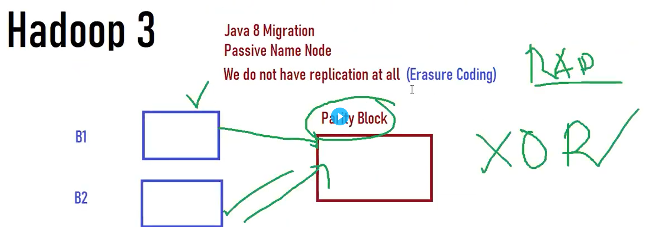

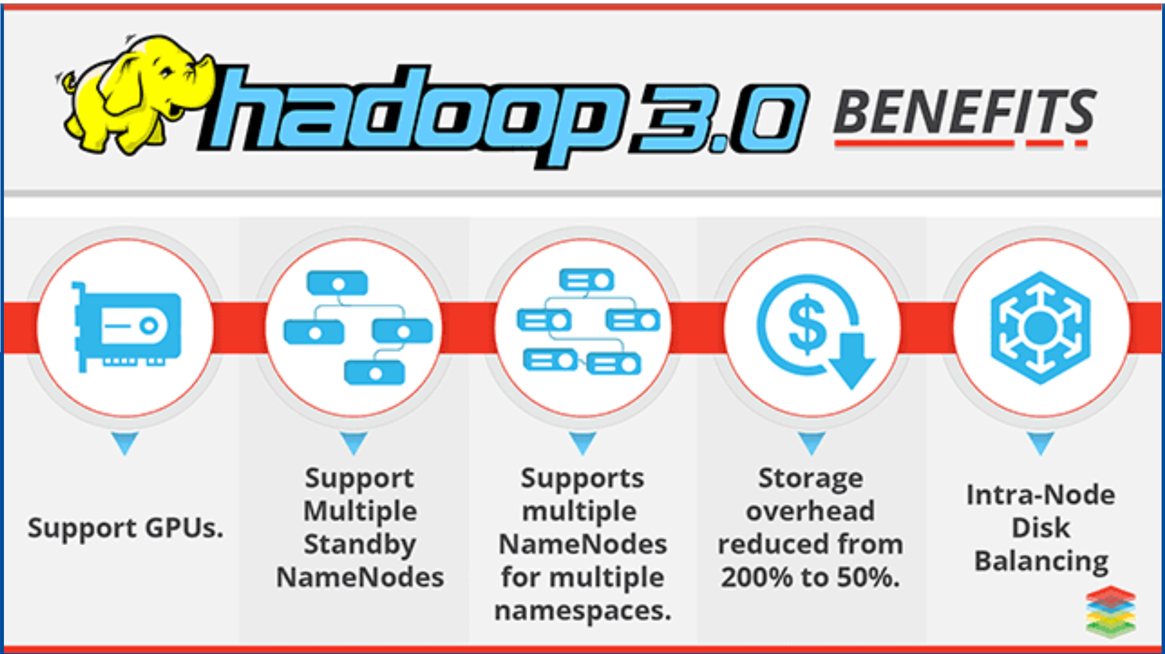

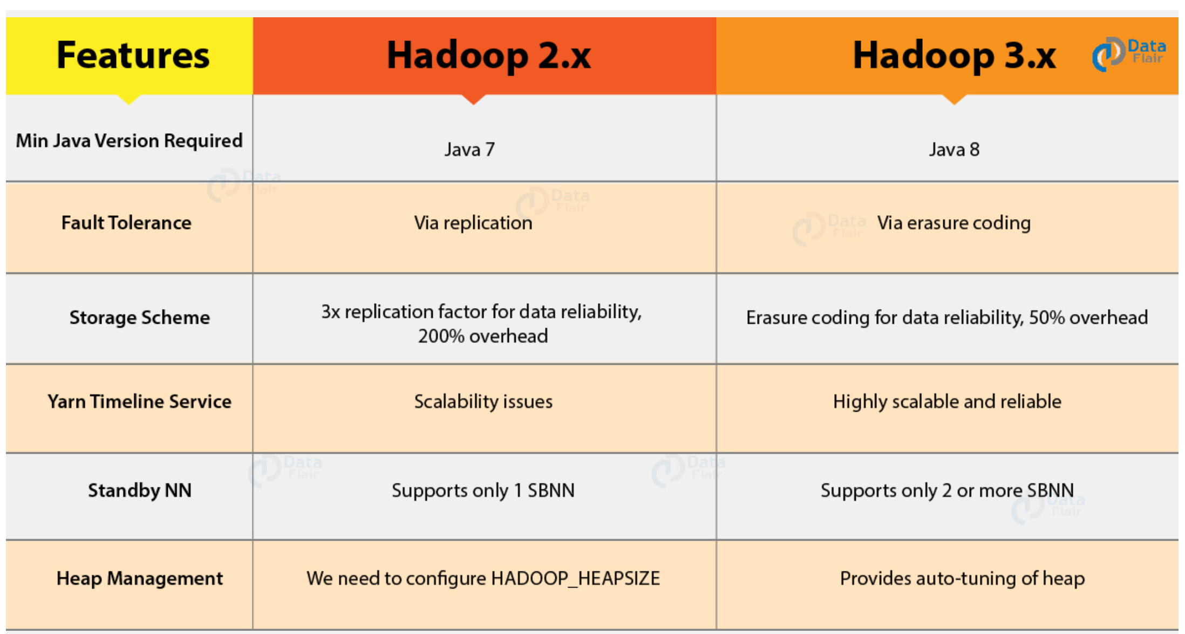

--java 8 migration

--multiple passive name nodes available

--we do not have replication at all (Erasure Coding)

* Block 1 and block 2 made a parity block
* 33 –40% reduction of cluster size (data size)
* RAID: Redundant array of inexpensive disk

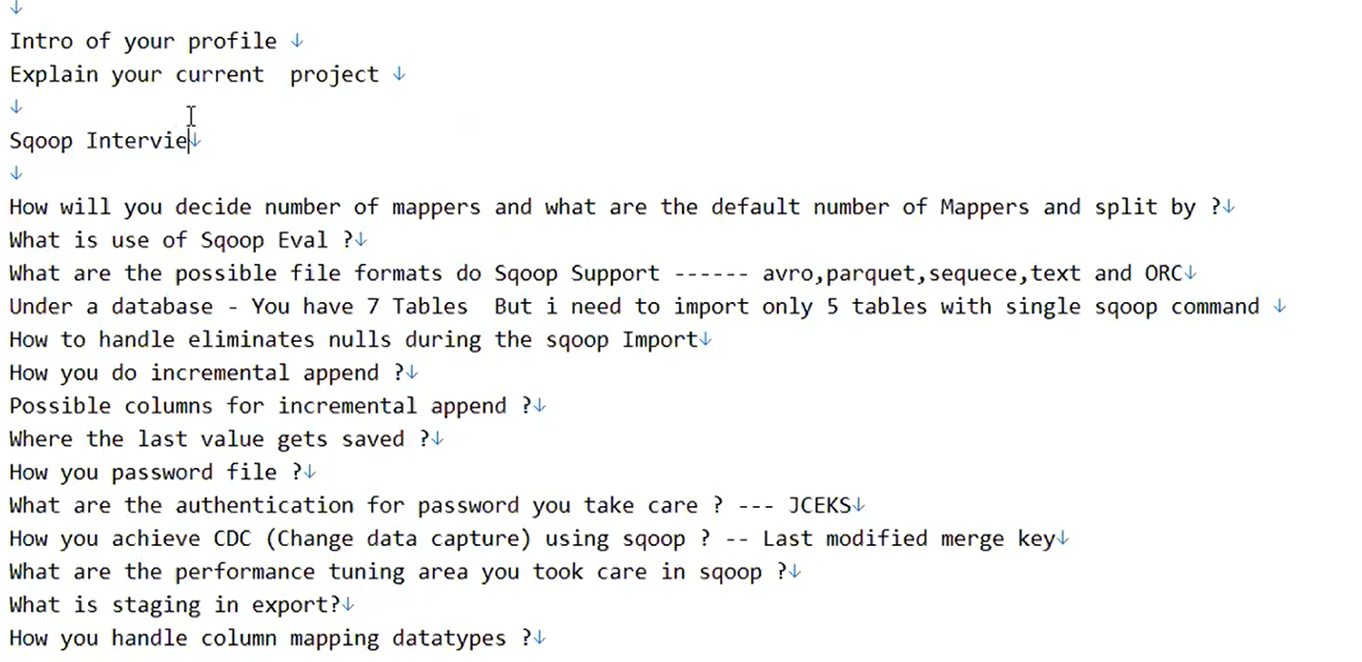

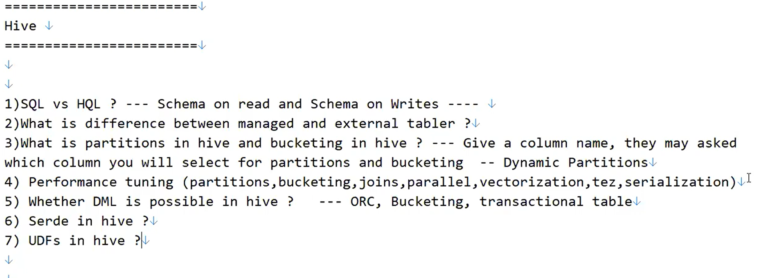

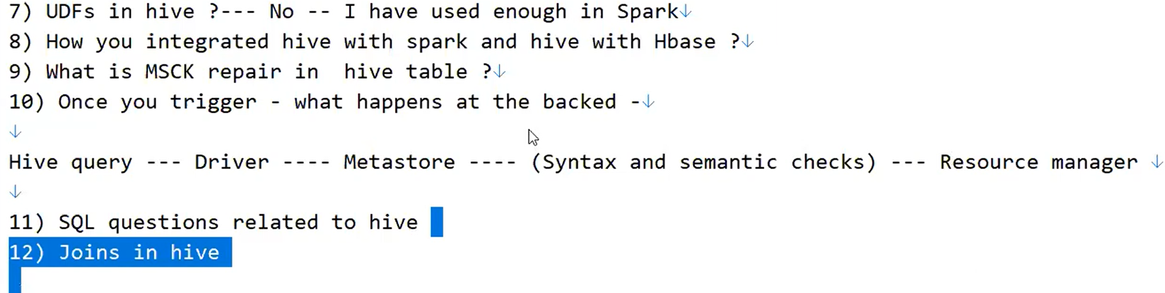

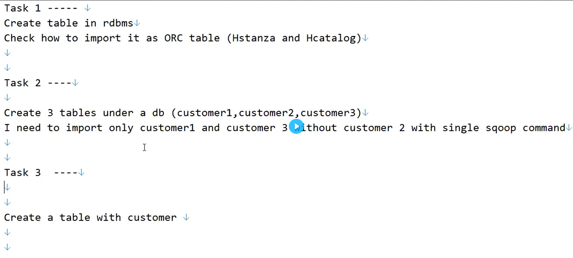

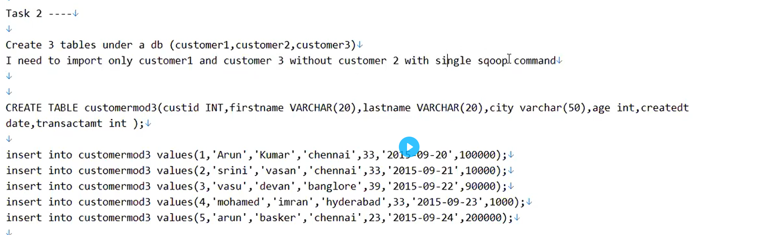 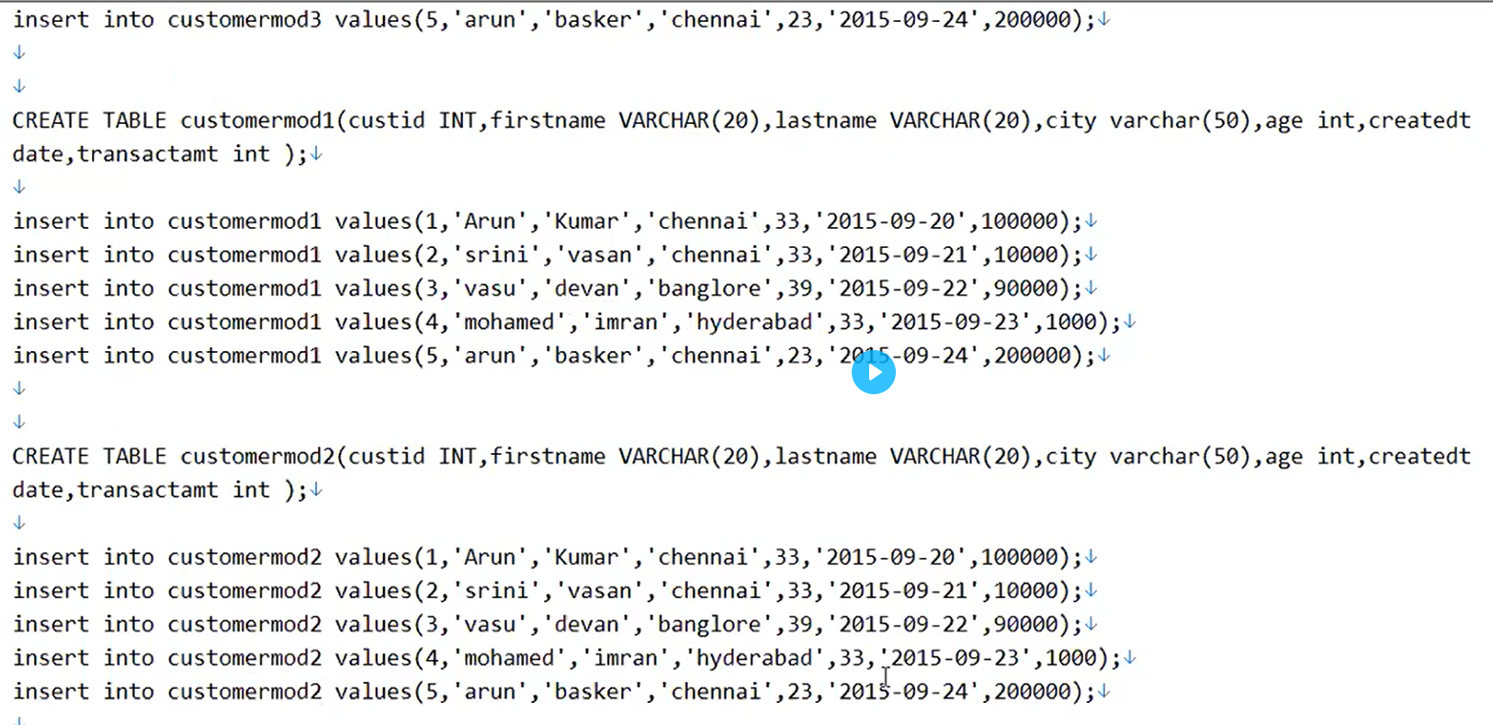

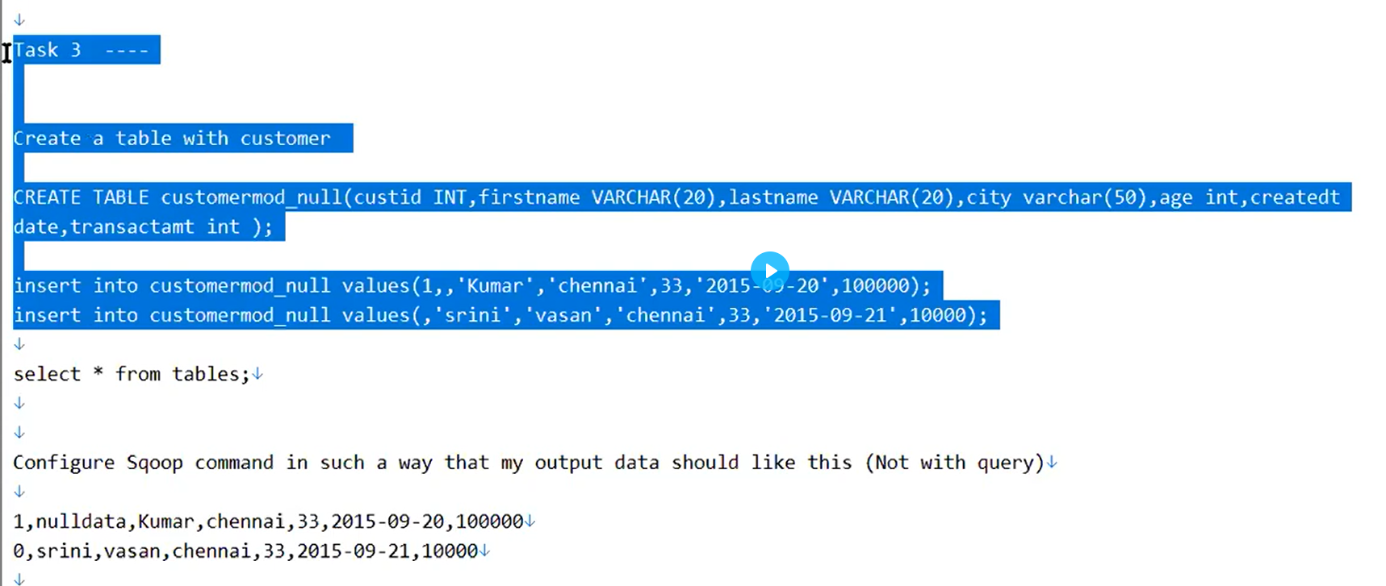

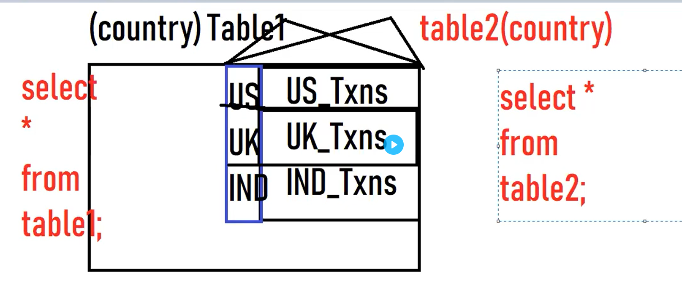

--tabl2 can’t show results as partitions created by table 1.



